Olusegun Afolabi
EECE 412
Professor Wenjie
2/6/2025
Lab 1: Even Detector
Introduction
The purpose of this lab was to design, implement, and test an even detector using the Basys 3 FPGA board. The circuit was developed using VHDL and implemented in Vivado 2024.2. The design takes three input switches and determines whether the number represented is even, lighting up an LED if the condition is met.
Overview of Tools Used:
- Vivado 2024.2 – FPGA Design Software
- Basys 3 FPGA Board – Hardware platform
- VHDL – Design language for logic implementation
Objective:
- Implement the even detector circuit in VHDL.
- Modify the constraint file to map inputs and outputs to the Basys 3 board.
- Synthesize, implement, and program the FPGA with the design.
- Verify the circuit operation using different switch combinations.
Concept
An even detector checks whether a three-bit binary number is even. If the number is even, the LED lights up.
The logic equation for the even detector is structured by evaluating the binary inputs. The following conditions are met when the number is even:
- The number is zero
- The number has ones at specific positions that maintain even parity
The input consists of three switches labeled a zero, a one, and a two, representing a three-bit binary number. The output labeled ‘even’ will be high when the input represents an even number.
The logic function for the even detector is constructed using basic logical operations:
- NOT operations are used to invert individual bits
- AND operations are used to check specific bit combinations
- OR operations are used to combine the results into a single output
The components involved in the design are:
- Switches sw 2 to sw 0 as inputs representing the three bit binary number
- LED 0 as the output indicating whether the number is even
The logical process involves evaluating combinations of the input bits to determine if the number is even and setting the output LED accordingly.
Component Functions:
- Switches (SW2 - SW0): Represent a 3-bit binary number.
- LED (LED0): Lights up if the number is even.
Procedure
- Project Setup in Vivado:
  - Created the "lab1_even_detector" project.
  - Selected Basys 3 board and set the target language to VHDL.
- VHDL Code Implementation:
  - Copied and saved the provided even_detector.vhd file.
  - Added it as a design source in Vivado.
- Constraint File Modification:
  - Edited the Basys3_Master.xdc file:
    - Assigned a(2:0) to Switches SW2-SW0.
    - Assigned even output to LED0.
Edited Constraint File Snippet:
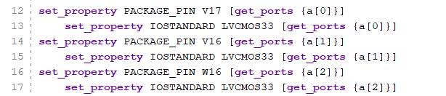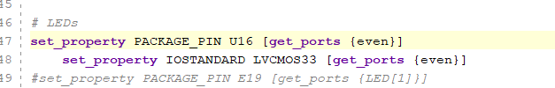

- Synthesis, Implementation, and Bitstream Generation:
  - Synthesized the design.
  - Implemented the synthesized design.
  - Generated the bitstream file.
- FPGA Programming and Testing:
  - Connected the Basys 3 board to the laptop.
  - Turned on the board and connected it to Vivado.
  - Programmed the FPGA with the generated bitstream.
  - Tested various input combinations.
Simulation and Implementation Results
The following images show different input switch configurations and their corresponding LED states.
- All switches off (000): LED is ON (Even)
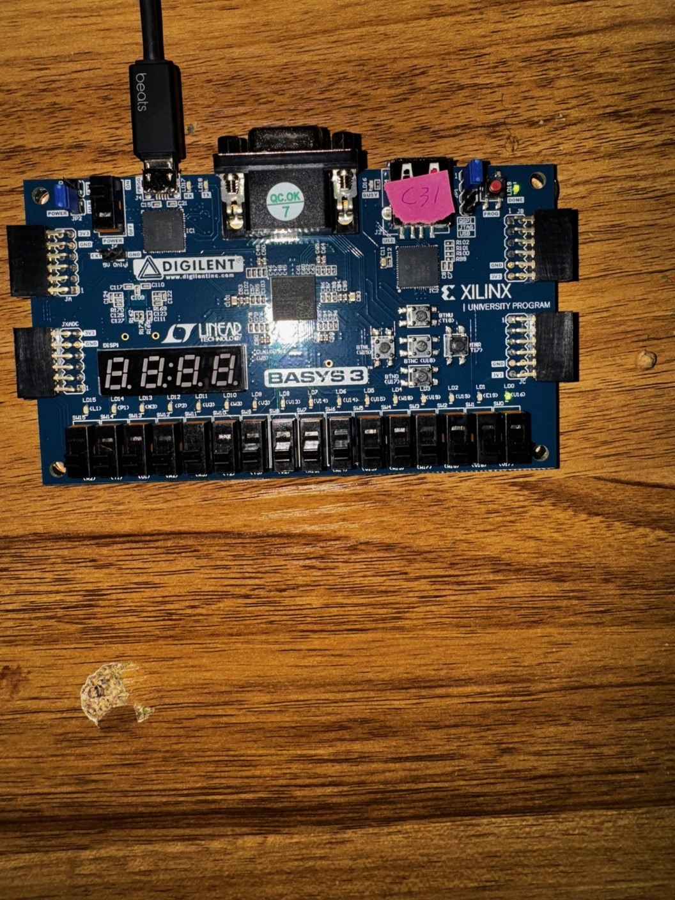
- One switch on (SW0 = 1, 001): LED is OFF (Odd)
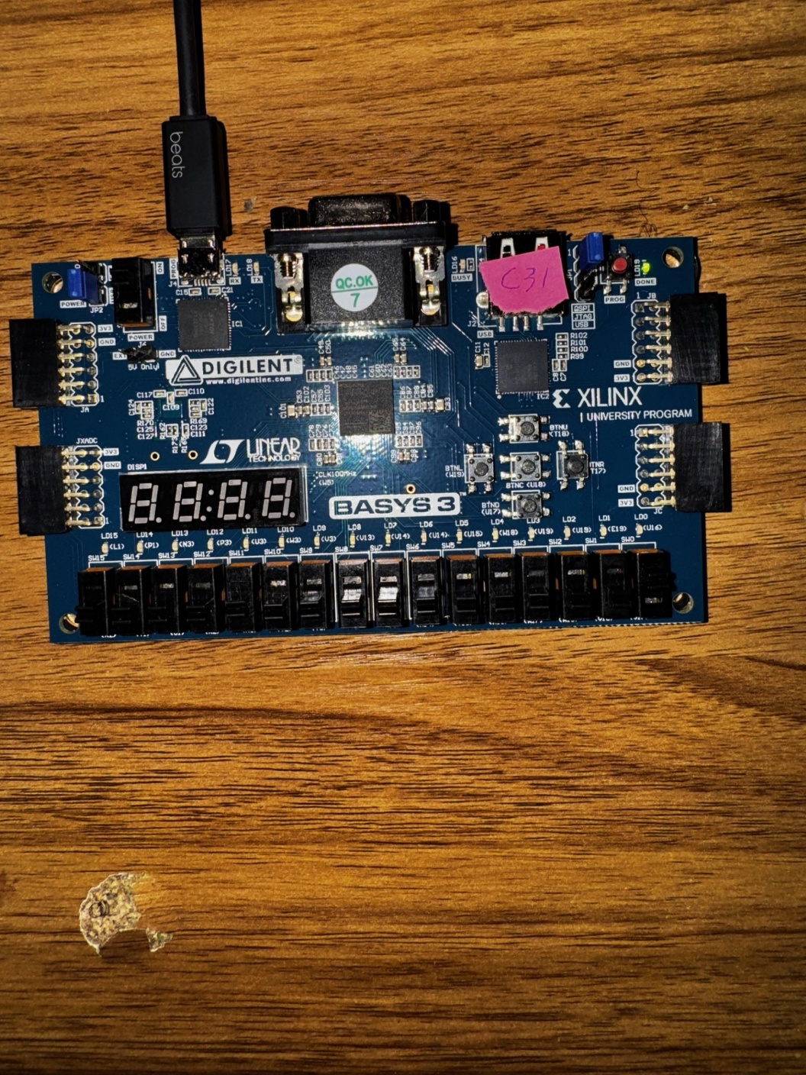
- Two switches on (SW0 & SW1 = 011): LED is ON (Even)
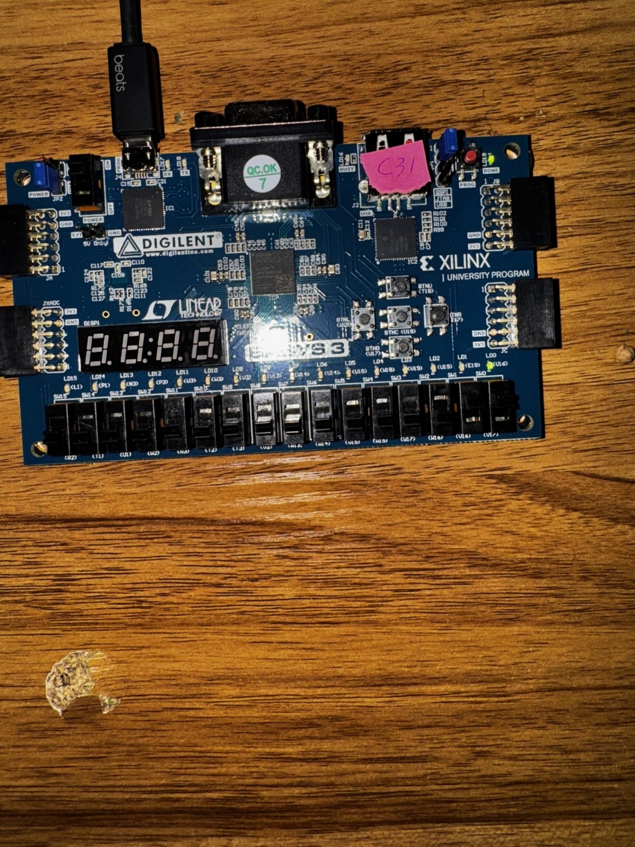
- Two switches on (SW1 & SW2 = 110): LED is ON (Even)
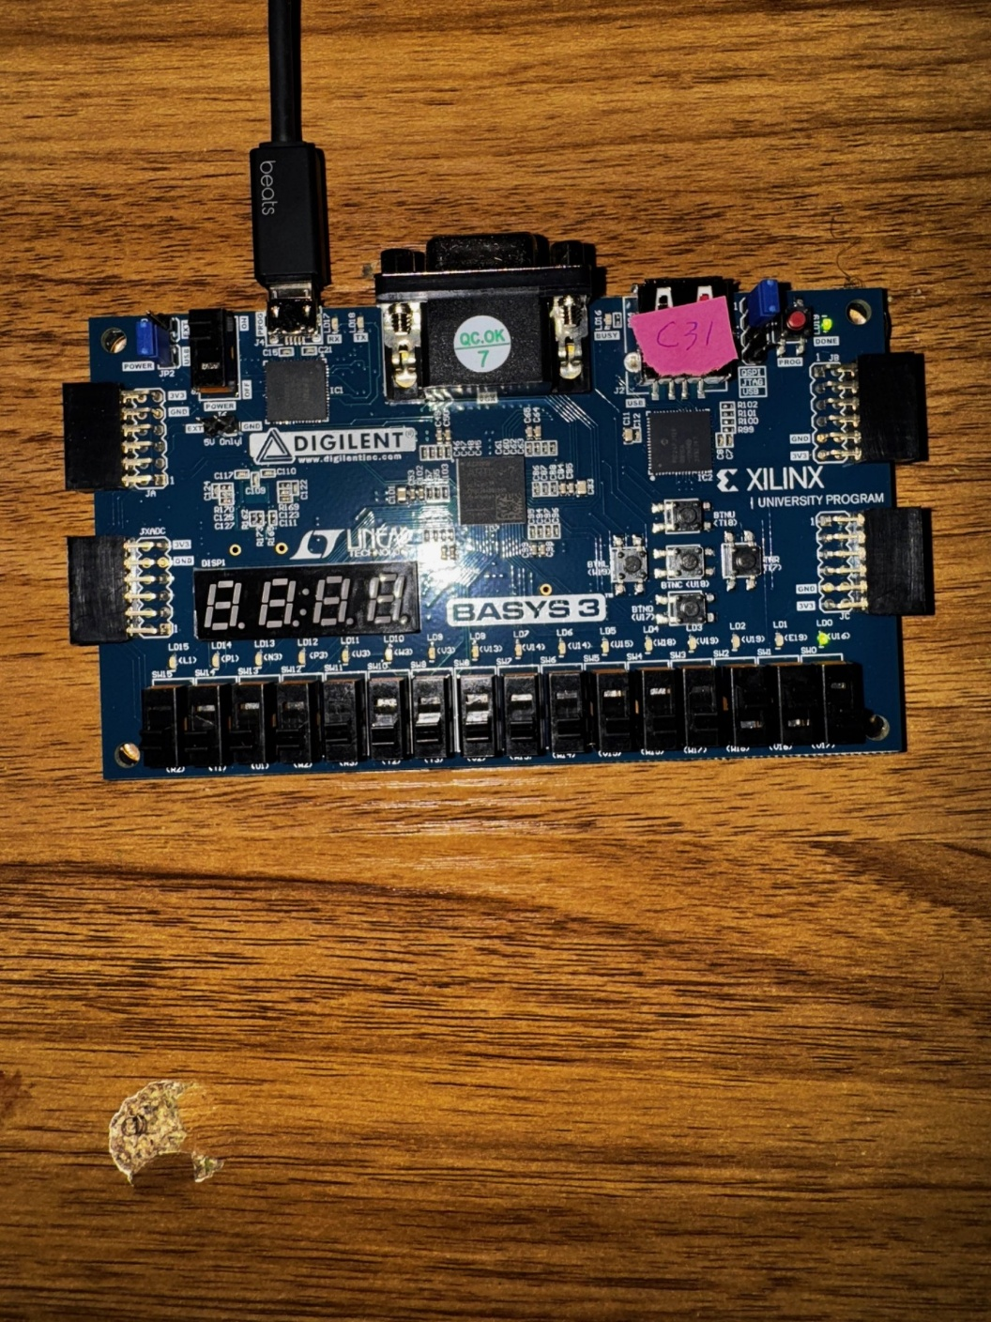
- All switches on (111): LED is OFF (Odd)
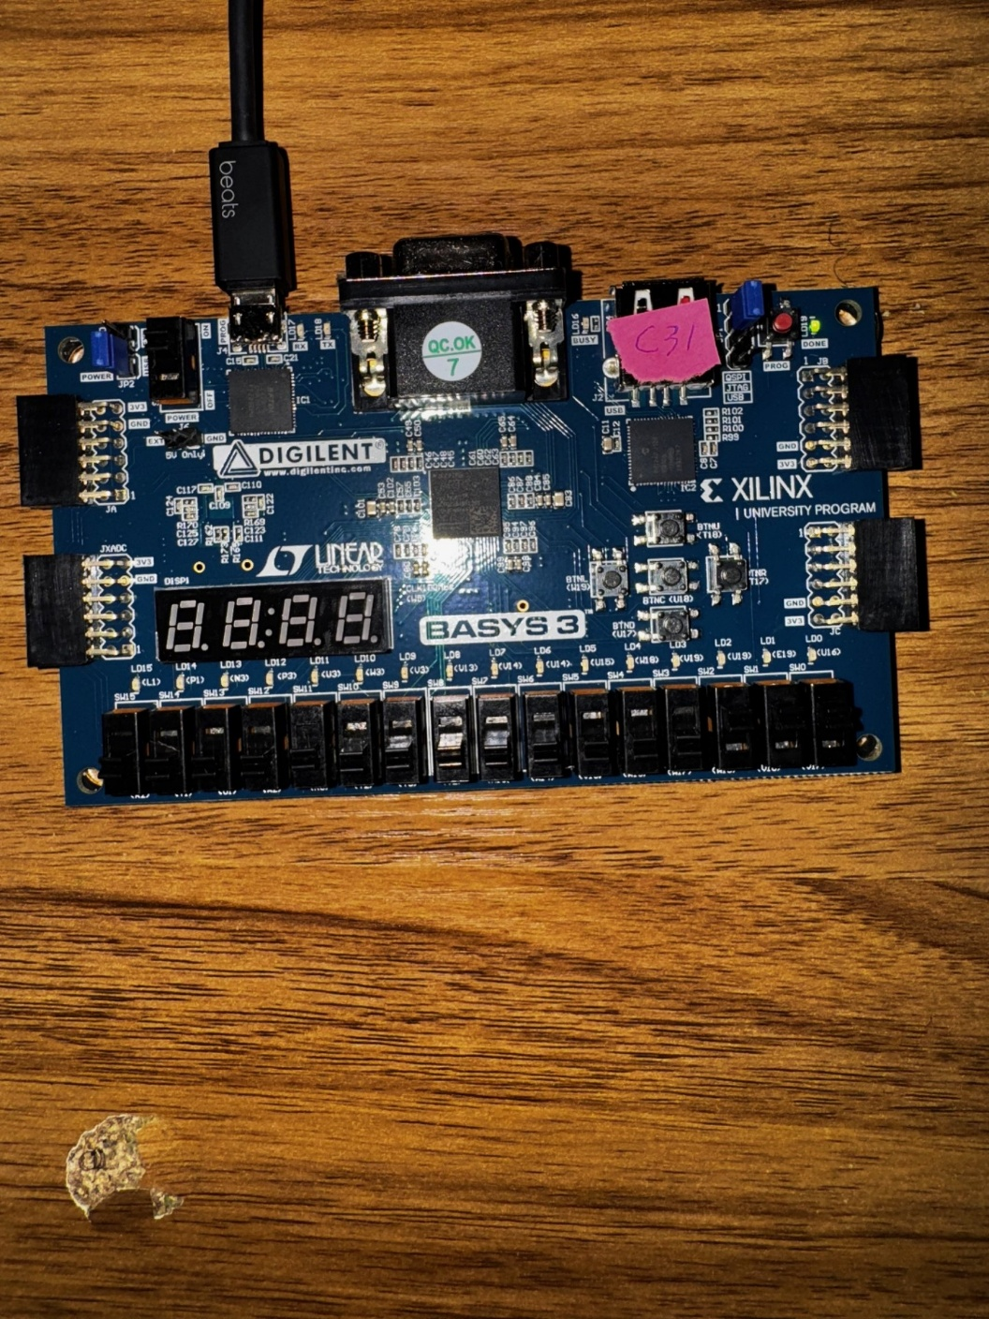
Explanation of Results
- The circuit successfully detected even numbers and lit up the LED accordingly.
- Even detector logic equation was verified through multiple test cases.
- The LED turned on when the input binary number was even and stayed off when odd.
- The constraint file changes correctly mapped inputs (switches) and outputs (LEDs).
Conclusion
- Summary: The even detector was successfully implemented, synthesized, programmed, and tested on the Basys 3 FPGA. The design correctly identified even numbers and controlled the LED accordingly.
- Lessons Learned:
  - Importance of Constraint Files: Ensuring correct mapping between FPGA pins and design ports is crucial.
  - Debugging in FPGA Design: Testing multiple switch combinations helped validate the circuit.

